LET’S VIKAS

A PROJECT REPORT

BY TEAM NO. 16

MEHUL TYAGI (E17CSE085)

SHOUVIK CHATTERJEE(E19CSE021)

HARSHIT SINGH (E19CSE309)

GAURANG SHUKLA (E19CSE341)

SUBMITTED TO

DEPARTMENT OF COMPUTER SCIENCE ENGINEERING BENNETT UNIVERSITY

GREATER NOIDA, 201310, UTTAR PRADESH, INDIA

NOVEMBER 2020

# DECLARATION

We hereby declare that the work which is being presented in the report entitled “Let’s Vikas”, is an authentic record of our own work carried out during the period from JUNE, 2020 to November, 2020 at Department of Computer Science and Engineering, Bennett University Greater Noida.

The matters and the results presented in this report has not been submitted by us for the award of any other degree elsewhere.

Signature of Candidate

Mehul Tyagi

(Enroll. No. E17CSE085)

Shouvik Chatterjee

(Enroll. No. E17CSE021)

Harshit Singh

(Enroll. No. E17CSE309)

Gaurang Shukla

(Enroll. No. E17CSE341)

# ACKNOWLEDGEMENT

We would like to take this opportunity to express our deepest gratitude to our mentor, **Dr. Shakti Sharma** for guiding, supporting, and helping me/us in every possible way. We were extremely fortunate to have him as our mentor as he provided insightful solutions to problems faced by us thus contributing immensely towards the completion of this capstone project. We would also like to express our deepest gratitude to VC, DEAN, HOD, faculty members and friends who helped us in successful completion of this capstone project. Any other name you can mentioned here. (Acknowledgement is your personal view, so you can write it in your way by maintaining integrity of technical report).

Signature of Candidate

Mehul Tyagi

(Enroll. No. E17CSE085)

Shouvik Chatterjee

(Enroll. No. E17CSE021)

Harshit Singh

(Enroll. No. E17CSE309)

Gaurang Shukla

(Enroll. No. E17CSE341)

TABLE OF CONTENTS

ACKNOWLEDGEMENTS iii

TABLE OF CONTENTS…………………………………………………………………………iv

LIST OF TABLES vi

LIST OF FIGURES viiii

LIST OF ABBREVIATIONS viii

ABSTRACT ix

1. INTRODUCTION 1

1.1. Problem Statement 1

2. Background Research 2

2.1. Proposed System 2

2.2. Goals and Objectives 2

3. Project Planning 3

3.1. Project Lifecycle 3

3.2. Project Setup 3

3.3. Stakeholders 4

3.4. Project Resources 4

3.5. Assumptions 5

4. Project Tracking 5

4.1. Tracking 5

4.2. Communication Plan 6

4.3. Deliverables 7

5. SYSTEM ANALYSIS AND DESIGN 8

5.1. Overall Description 8

5.2. Users and Roles 8

5.3. Design diagrams/ UML diagrams/ Flow Charts/ E-R diagrams 9

5.3.1. Use Case Diagrams 9

5.3.2. Class Diagram 10

5.3.3. Activity Diagrams 11

5.3.4. Sequence Diagram 12

5.3.5. Data Architecture 13

6. User Interface 14

6.1. UI Description 14

6.2. UI Mockup 14

7. Algorithms/Pseudo Code 15

8. Project Closure 16

8.1. Goals / Vision 16

8.2. Delivered Solution 16

8.3. Remaining Work 16

REFERENCES 17

LIST OF TABLES

Table Page

Table 1: Goal and Objectives 4

Table 2: Decision Description 5

Table 3: Stakeholder 5

Table 4: Resources Required 5

Table 5: Assumptions 6

Table 6: Project Tracking 6

Table 7: Regularly Scheduled Meetings 7

Table 8: Information To Be Shared Within Our Group 7

Table 9: Information To Be Provided To Other Groups 7

Table 10: Information Needed From Other Groups 8

Table 11: Deliverables 8

Table 12: User and Roles 9

LIST OF FIGURES

Figure Page

Figure 1: Sample use-case diagram 9

Figure 2: sample 2 11

Figure 3: sample 3 12

Figure 4: Sample 4 13

Figure 5: Sample 5 13

Figure 6: Sample 6 14

LIST OF ABBREVIATIONS

Abbreviation Explanation of the Abbreviation

SQL Structured Query Language

UI User Interface

NGO Non -Government Organisation

ABSTRACT

Let’s Vikas is primarily free of cost platform for NGOs and organizations working in sectors like social welfare, environmental welfare , educational welfare, economic welfare and Indian culture and heritage; startups with new ideas and products that don’t already exist in the market. The core idea is to raise awareness amongst the people. Let's Vikas is a website that aims to revive this rich culture by providing a platform for different beneficiaries to showcase their products and art. Products displayed may include handloom clothes, clay utensils, wooden artifacts, etc. Through this website, we also aim to give opportunities to various Ngo's to raise funds for their operations. The user can look for different organizations that work for divergent social causes and support them based on his liking. “Lets Vikas” is a step towards encouraging the Aatm Nirbhar Bharat Abhiyaan.

1. INTRODUCTION
   1. Our Project “Lets Vikas” is a step towards encouraging the Aatma Nirbhar Bharat Abhiyaan. Through our project, we will be encouraging the rich and ancient tradition of India. We will be helping the NGOs in reaching to a larger audience. We will promote the growth of all the sectors in different fields like Cultural, Agriculture, Education, Economy, etc. by providing them a platform where they could reach to the world. People can donate in NGOs working in different fields like the plantation of trees. The ancient art and craft of our country could now reach every house like the Thanjavur painting from Tamil Nadu could now be available for buying and thus the people making them will get huge support. By our initiative we want to be vocal for our local products. On our website we will be listing upcoming Indian Startups that are providing various services and products to the Indian consumer.
   2. Problem Statement

The project addresses the problems as follows. Skilled personal in Indian traditional and cultural arts do not find a way to show and teach their practice to the rest of the country. The NGO’s are not able to reach a larger audience for awareness of the need for help in the country. Most of the quality Indian startups that can be an alternative to foreign goods or services never reach the consumers. People are not aware of their existence, therefore, they do not use them.

1. Background Research

India was once a well-known center throughout the world for its rich local culture and tradition. After every hundred miles in India, the language changes, tradition changes, and comes flavor of the region into play. Yet, with a booming consumer base and digital evolution, this cultural uniqueness is slowly disappearing, while its importance and value are only recognized by a few. Today, there are only a few handicraft workers left who practice their art with traditional tools and techniques, while most of them have switched to the use of modern machinery that lacks finesse. Through our website, we desired to preserve and promote this traditional art. Another motive to adopt this project was to support homegrown entrepreneurs and startups that are likely to be lost on their home turf. In India, startup culture has recently begun to take long strides, but the local companies and small businesses are not its front runner due to fewer eyeballs and funding. There are various articles by leading business magazines that support the above claim.

There were many solutions that crossed our minds when the team conducted its first brainstorming session, but nothing consolidated. We then looked up to the existing solution that is present in the market like kikstarter.com, letsVenture.com, Mitticool, etc. These ventures addressed the problem to some extent. We then decided to survey to get an opinion of different people on this particular problem. Hundred and forty-eight people were a part of this survey. Their answers got recorded with the help of Google Forms. Out of those one hundred and forty-eight respondents, 130 felt that we should make a website and promote these arts and small businesses. During our research, we realized that there are various NGO's that do some great work, but they do get little recognition and support from the citizens. To solve the problem we decided to add a section on our website where the common can know of different NGOs and their work and support them in any form they like.

To see how an NGO work, the team interacted with various volunteers that work for different organizations. Through them, we came to know their work in detail and their day to day struggle in running their operations. We also went through different articles online that cautioned us how some ill intention NGO might fool innocent users. The expected success of our project becomes more evident as there are no similar functioning website or applications available in the market. Currently, there are application based on a particular NGO. Websites like ( <https://www2.fundsforngos.org/> ) which only contains information only regarding the NGOs and there work but our website is an initiative for the upliftment of the Indians who need our support and the people all around the world can support. As per article( <https://www.searchenginejournal.com/how-to-make-a-successful-website/257617/#close> ) , the success of a website depends on defining goals, earning trust, standout factor, easy User interface, analytics and feedback from the user on which we are working unfaltering to ensure the success of our website. After researching our project and reading the experts from the industry, the team is motivated to create a well-connected and fluid website.

Also to mention our project is unlike any other existing project. Our sole motive is to promote social welfare, environmental welfare, educational welfare, economic welfare, and Indian culture and heritage. We not only support NGOs but, all the organizations or a group of people trying to do something new or trying to help the country.

* 1. Proposed System

Our team has come together to bring about a change in society and help our country progress to a brighter future. It is our aim to provide a platform for the people who are out there for a change. Let's Vikas being our first project has been specifically tailored for the growth of social and economic sectors. Our team focuses on sectors like innovation, economy, education, and equality. We feel that these sectors must be focused upon to help build an innovative and self-reliant nation. Through our platform, we aim to give every individual a voice who desires to contribute to nation-building. We aim to connect both creator and consumer through our platform.

* 1. Goals and Objectives

Our goal is to make our website easy to use, functional with an interactive interface. We aim to build a website that can easily be managed and is coherent. The content should be easily navigatable and it should be responsive.

Table : Goal and Objectives

|  |  |
| --- | --- |
| **#** | **Goal or Objective** |
| 1 | Make the website easy to use. |
| 2 | Make the website functional and responsive. |
| 3 | Make the design of the website attractive. |
| 4 | The content of the website should be readable and provide value to the user. |
| 5 | Build a robust website. |

1. Project Planning

This section covers the details of the project planning. Selecting the lifecycle of the development, project stakeholders, resources required, assumptions made (if any) are detailed in the sections below.

* 1. Project Lifecycle

The team has used a simple waterfall approach to make this water.

* The requirements were first recognized.
* After the brainstorming session, the website design was finalized.
* The individual task among the team members were distributed.
* Discussion with the mentor took place.
* Work on project documentation done simultaneously.
  1. Project Setup

The basic project decisions that will be used on this project are given in the table.

Table : Decision Description

|  |  |
| --- | --- |
|  | **Decision Description** |
| 1 | Designed the front end using HTML-5,css and Bootstrap. |
| 2 | Designed the back end using Java script, JQuery and php. |
| 3 | SQL is used for the database of the website. |
| 4 | Planning to make the UI more intuitive and easy to use. |

* 1. Stakeholders

All the stakeholders for this project are mentioned below in the table along with their specified roles.

Table : Stakeholder

|  |  |
| --- | --- |
| **Stakeholder** | **Role** |
| Dr. Tapas Badal | Mentor |
| Dr. Shakti | Mentor |
| Shouvik Chatterjee | Team member |
| Mehul Tyagi | Team member |
| Harshit Singh | Team member |
| Gaurang Shukla | Team member |

* 1. Project Resources

The resources required for the project are mentioned in the table below. All the resources are available at our disposal.

Table : Resources Required

|  |  |  |
| --- | --- | --- |
| **Resource** | **Resource Description** | **Quantity** |
| SQL Database | SQL is a domain specific language used in programming and designed for managing the data. | 1 |
| Eco Web Hosting | For hosting website. | 1 |
| Capstone Team | Our team of students who will be the primary developers of the project. | 4 |
| Dr. Shakti Sharma | The mentor who will be able to provide us with technical assistance. | 1 |
| Windows Workstation | An windows workstation with bracket installed for developing the website and testing. | 4 |
| Bootstrap | A potent front-end framework used to create modern website and web apps. | 1 |
| Android Phone | An Android phone to be used for testing website. | 1 |

* 1. Assumptions

Due to the ongoing pandemic followed by a lockdown and continuation of online classes, the assumptions are modified accordingly.

Table : Assumptions

|  |  |
| --- | --- |
|  | **Assumption** |
| A1 | The capstone team and mentors will be able to meet via Microsoft Teams, once a week. |
| A2 | SQL Database is free to use and accessible to all team members for the initial stages. |
| A3 | Team members will be take web development course on Udmey. |
| A4 | Team will have sufficient time to complete a working model to present by mid-semester |
| A5 | Front End and backend functionality will be completed in time. |
| A6 | Team members will time to learn necessary skill for the completion of the project. |
| A7 | The functionality of the website will be enhanced with time for better user experience. |

1. Project Tracking
   1. Tracking

All the steps of the project were monitored and everything relevant to the project was stored.

**Example:**

Table : Project Tracking

|  |  |  |
| --- | --- | --- |
| **Information** | **Description** | **Link** |
| Code Storage | Project code will be stored in GIT repository. | Link |
| Bug Tracking | Bug tracking will be done while discussing the code with team mate. | Link |
| Project Documents and Assignments | Weekly reports, specification and design documents, etc. will be stored in our Google Drive. | Link |

* 1. Communication Plan

The communication was done on Microsoft Team and discord with the team mentor while Google Meet was used to communicate among the team members, throughout the working of this project

Table : Regularly Scheduled Meetings

|  |  |  |
| --- | --- | --- |
| Meeting Type | Frequency/Schedule | Who Attends |
| Conference Call | Weekly | Project team and Mentor |
| Team Meeting | Weekly | Project team |
| Short Meeting | Twice in a Week | Project team |
| Review Meeting for project progress | Weekly | Project team and Mentor |
| Work Updates Meeting | In every two weeks | Project team |

Table 8: Information To Be Shared Within Our Group

|  |  |  |  |
| --- | --- | --- | --- |
| Who? | What Information? | When? | How? |
| Project team | Codes and designs for the websites. | Weekly | On google meet and discord server |

Table 9: Information To Be Provided To Other Groups

|  |  |  |  |
| --- | --- | --- | --- |
| Who? | What Information? | When? | How? |
| Mentor and other teams | Final deliverables | At completion of project | Project specification doc., code, Power Point presentation |
| Mentor | Weekly report and progress | Weekly | On Microsoft teams during DTI lab. |

Table 10: Information Needed From Other Groups

|  |  |  |  |
| --- | --- | --- | --- |
| Who? | What Information? | When? | How? |
| Mentor | Project queries and milestone explanation | Weekly | During the DTI lab |

* 1. Deliverables

All the basic documentation as well as link to the source code will be provided. Deliverables include website, blog page, presentation and video presentation.

All the documentation of the websites as well as the link to the source code is provided in the table of deliverables

Table : Deliverables

|  |  |
| --- | --- |
| **#** | **Deliverable** |
| 1 | Website |
| 2 | Code |
| 3 | Test and test results |
| 4 | Build process documents***(if any)*** |
| 5 | Install process documents***(if any)*** |
| 6 | Administrator or user manual***(if any)*** |
| 7 | Postmortem document |
| 8 | Final report (final PowerPoint presentation, 3 minute video, and final sprint) |

1. SYSTEM ANALYSIS AND DESIGN

This section describes in detail about the design part of the system.

* 1. Overall Description

This project is a web-based project where we have created a website in order to solve our problem. It is divided into three modules where each module represents different functionalities. The first module contains login and authentication, followed by a home page and navigation bar. The second module consists of a dashboard that indicates our current as well as previous activity.

The dashboards show the user his previous work and allow him to edit it. We have also provided an editor where users can design and place images in the article.  
The third module contains the viewing section where the users can look at the works and activities of other users.

* 1. Users and Roles

The various types of users who will be accessing the platform are mentioned below in the table with their corresponding roles.

**Example:**

Table : User and Roles

|  |  |
| --- | --- |
| **User** | **Description** |
| Organization/Indi-vidual | Who want upload about their work like NGOs, startups and skilled worker. |
| Dynamic User | Who want to help/ contribute to the startup or support skilled workers available at the platform. |
| Developer | This includes members who will help in maintenance and running of the website. |

* 1. Design diagrams/ UML diagrams/ Flow Charts/ E-R diagrams

<<provide all the diagrams that were created during the design phase of your project. Some examples are in sections below:>

* + 1. Use Case Diagrams

<< Provide any use-case diagrams that are being used as part of the project. Uniquely label each use case so that if necessary, it is easy to reference from other parts of the document. >>

**Example:** Restaurant system

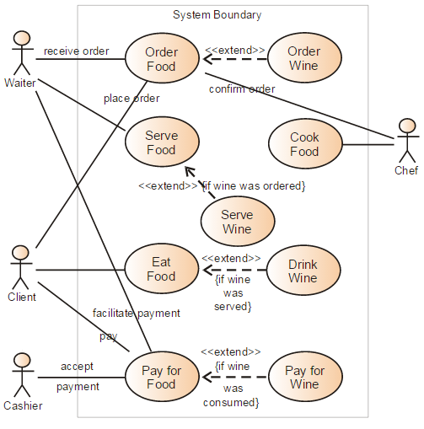

Figure : Sample use-case diagram

<<to insert caption for tables and figures, click on references on the top menu, under captions section 🡪 click insert caption 🡪 choose label as table

If you use a table, figure, or non-text item that is not your original design, you must cite the original source of the item. You may use an in-text citation in the text of the title or caption of the item, or you may include the citation as a footnote. Refer to the style manual of your discipline for more information about citations of non-text items.>>

* + 1. Class Diagram

<< Include a class diagram for all classes to be designed. Optionally include major data elements of those classes and important methods and functions that will be used by other classes.>>

**Example:** Online Photo Collection

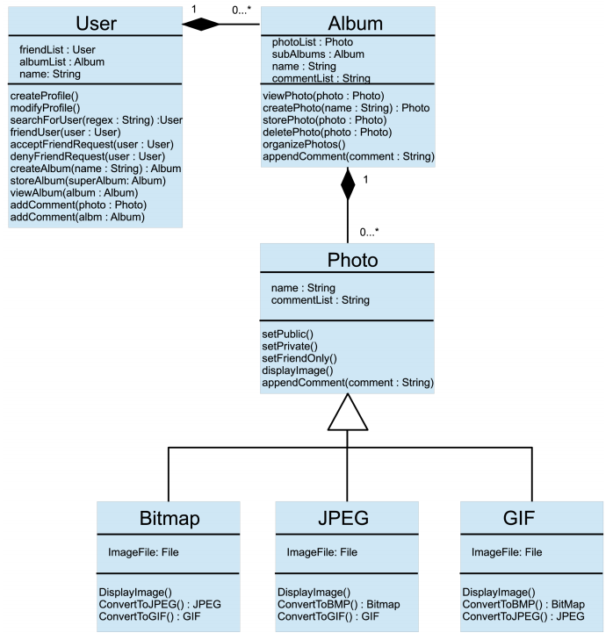

Figure : sample 2

* + 1. Activity Diagrams

<< Include activity diagrams for important workflows in the program. At least one diagram should be included for the main workflow in the program. Optionally include labels that indicate which component is responsible for that part of the activity. Activity diagrams for components which perform complex tasks should also be included. >>

**Example**: View friend’s photo album

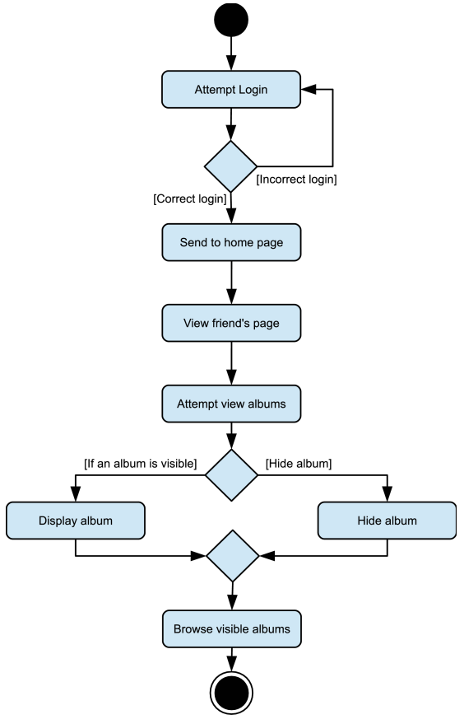

Figure : sample 3

* + 1. Sequence Diagram

<< Include sequence diagrams for important functionality of the program to indicate control flow. These diagrams should include classes found in the class diagram and use the methods for those classes to show the interaction between them. >>

Example: Create new album

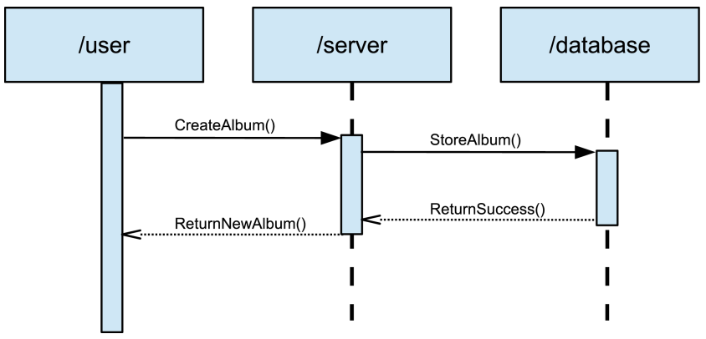

Figure : Sample 4

* + 1. Data Architecture

<< Include any information or diagrams that provide details about databases, xml configuration files, or other data structures that are a part of the system. If a very specific format is required, it may be worthwhile to provide a more robust description or a detailed design such as a database schema. >>

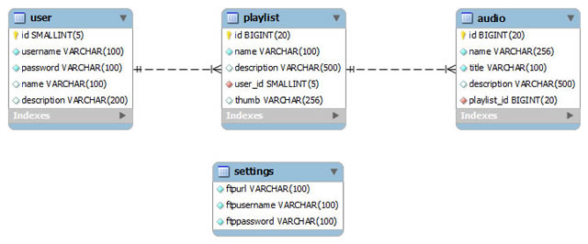

Figure : Sample 5

1. User Interface

UI DESCRIPTION AND MOCKUP

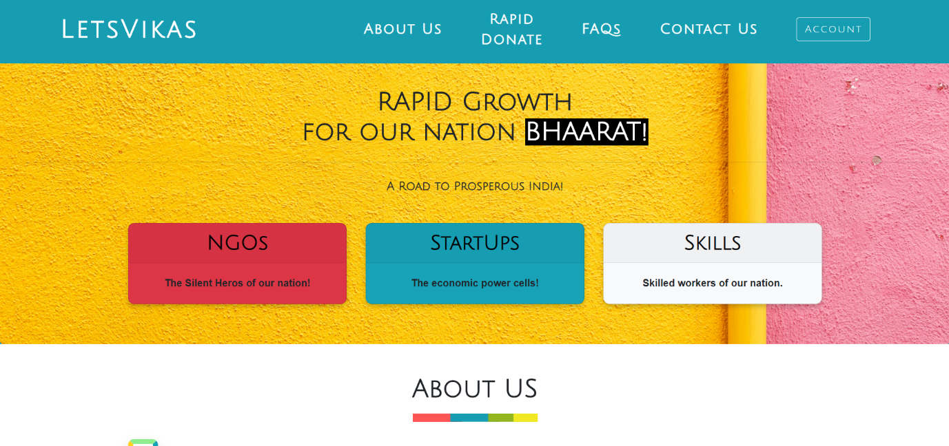

This is our home page or the landing page where the user will first land. Here user can login or sign up through the account section on the navigation bar. The user could browse through the different articles by choosing from the three container provided.

If user have certain queries than he can connect with us by clicking on contact us section.

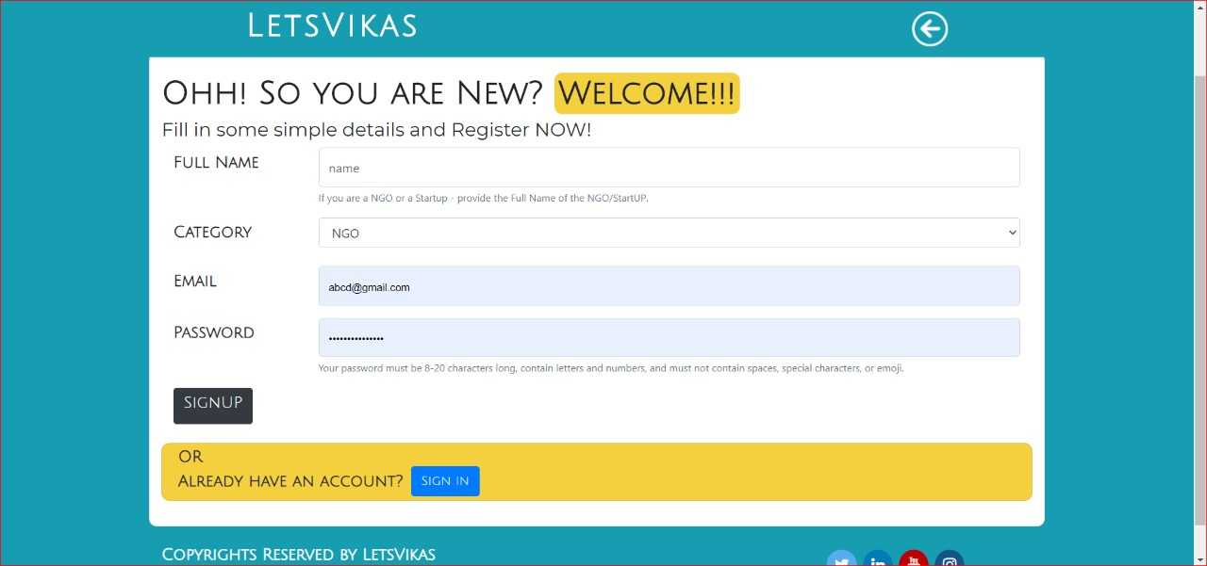

This is the sign up page where user could create his/her account by filling in the simple required details. User could select the category i.e. start-up, Ngo, Individual.

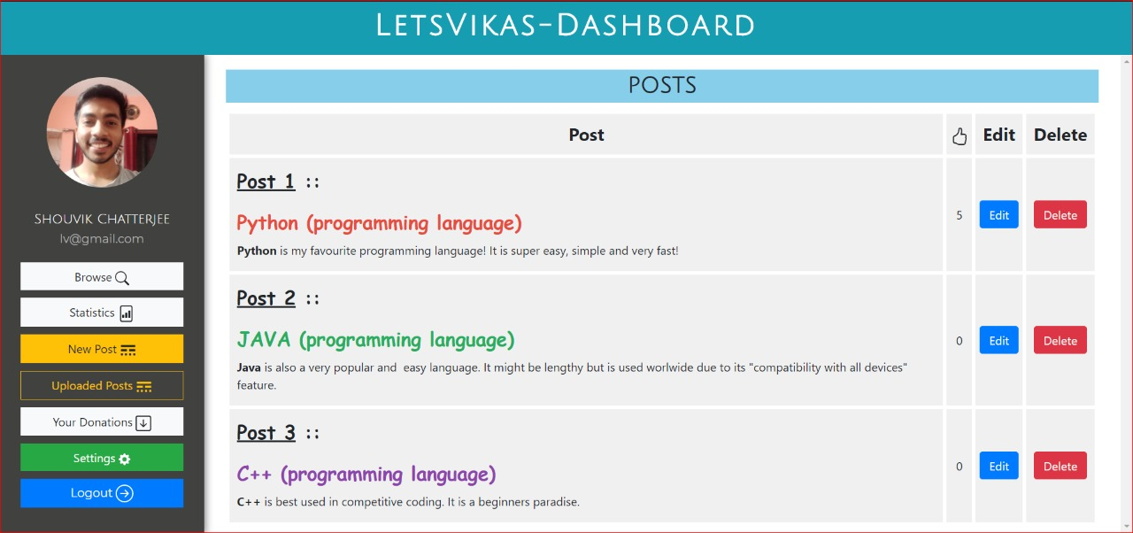

After logging in, the user will land up on the Dashboard where he could upload a post, see his previous posts and could edit and delete certain posts.

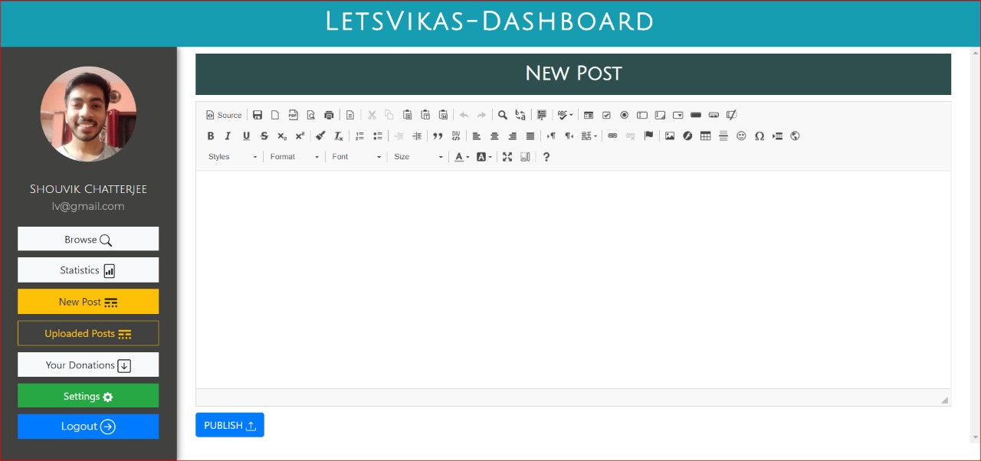

This is the editor page where a user could publish his article, work, images etc. in an appealing way to the world.

1. Algorithms/Pseudo Code

<<Include the proposed algorithm/pseudo code.>>

1. Project Closure

This section elucidates the overall lookup at the project and some of the future works that may enhance the solution.

* 1. Goals / Vision

The goal of our project was to provide a free of cost platform for NGOs and organizations working in sectors like social welfare, environmental welfare, educational welfare, economic welfare, and Indian culture and heritage; startups with new ideas and products that don't already exist in the market. The team has the vision to raise awareness among people while supporting and strengthening the ATAM NIRBHAR BHARAT movement. We believe that The heritage of our country could reach to the world and could become the new attraction for the world.

* 1. Delivered Solution

We have created a website as a direct response to the problem. On our website, we have created a separate section for each category. Problems related to NGOs, startups, and handicraft products are dealt with under their specific sections. Our team has provided a provision to connect various stakeholders directly. Startups can be connected to investors and consumers, NGOs can be connected to people and organizations who are willing to donate and skilled workers have a virtual marketplace, where they can sell their handicrafts and other products. We have also launched an information portal on the website itself that will help spread awareness among the community.

* 1. Remaining Work

We would make a payment gateway for an easy transaction on the website itself without redirecting it to other websites. We also intend to create a chatbot that will help resolve the query of our users and also reduce human effort on the website. We also look forward to create an intuitive and easy to use UI on the basic suggestions of our users.

REFERENCES

1. Udemy course link <https://www.udemy.com/course/the-complete-web-developer-course-2/learn/lecture/4672126#overview>

2.Startups supporting site <https://www.entrepreneur.com/topic/inspiration>

3.NGO’s to get an idea of their working <https://dreamgirlfoundation.ngo/>

4. <https://www.scnsoft.com/ecommerce/portals>